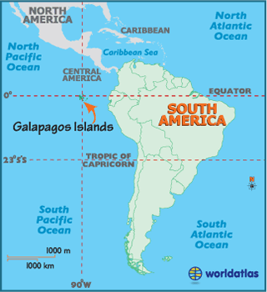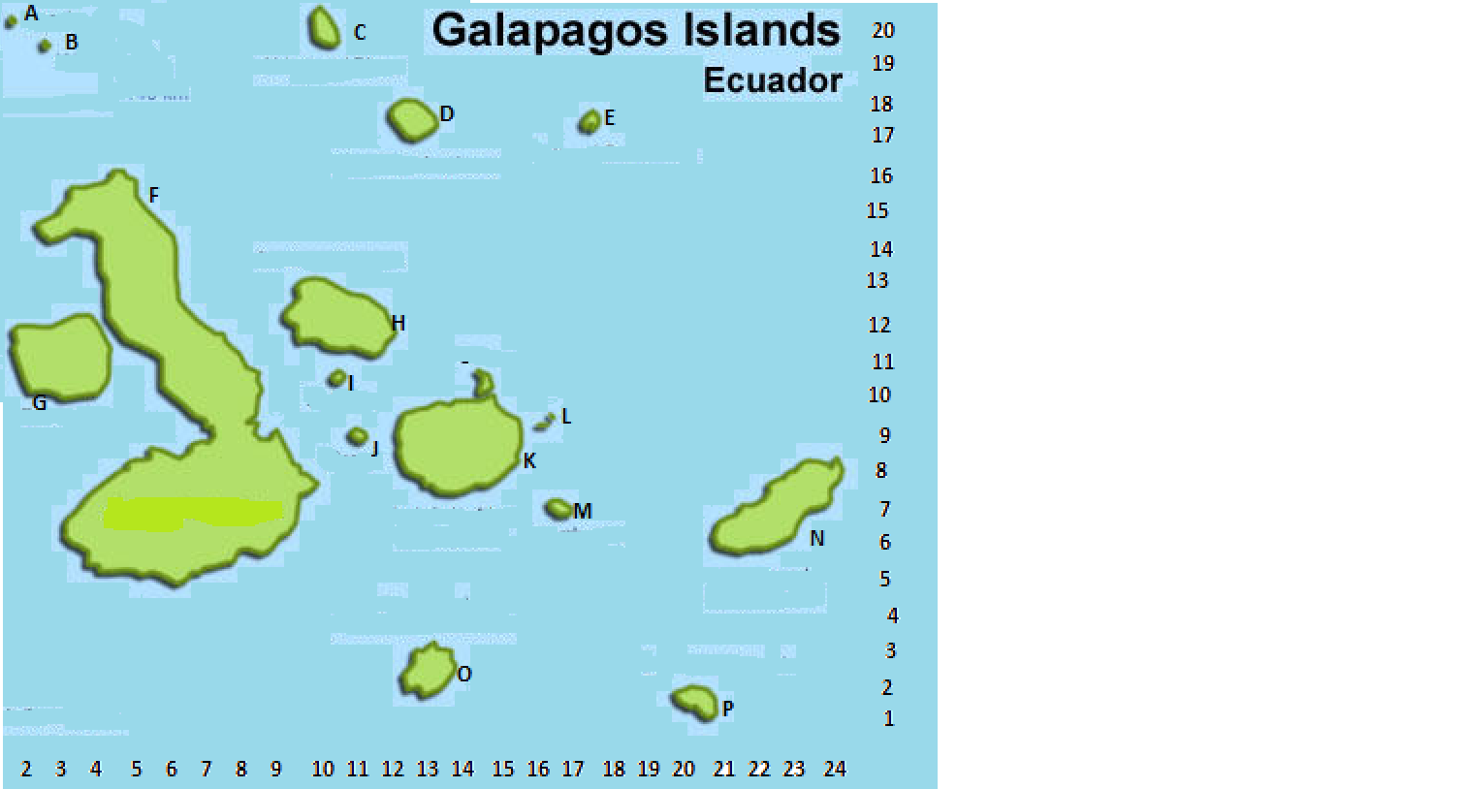

|  |  |  |  |  |
| --- | --- | --- | --- | --- |
| **NAME** | **DESCRIPTION** | **NORTH** | **EAST** | **LETTER** |
| Darwin | Barren rock | 20 | 1 |  |
| Espanola | Bushes and scrub | 1 | 20 |  |
| Fernandia | Humid Forest | 10 | 2 |  |
| Floreana | Lots of cactus | 2 | 13 |  |
| Genovesa | Bushes and scrub | 17 | 17 |  |
| Isabella | Mountains and trees | 5 | 3 |  |
| Marchena | Mountains and trees | 17 | 11 |  |
| Pinta | Mountains and trees | 20 | 10 |  |
| Pinzon | Dry Forest | 9 | 11 |  |
| Rabida | Humid Forest | 10 | 10 |  |
| San Cristobal | Lots of cactus | 6 | 21 |  |
| Santa Cruz | Dry Forest | 8 | 12 |  |
| Santa Fe | Lots of cactus | 7 | 16 |  |
| Santiago | Humid Forest | 12 | 9 |  |
| Wolf | Barren rock | 19 | 2 |  |