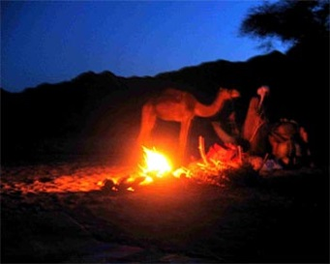**Zodiac**

The traveller sat by the fire and said

“Who knows why

Those tiny points of light up there

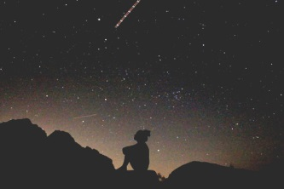Are walking across the sky?”

An old man spoke. “They’ve been put there

So we can find our way

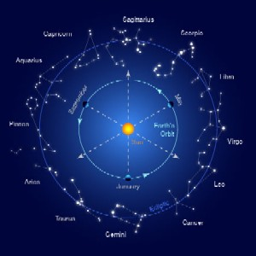They’re signposts across land and sea

When night has ended day

And so that we remember them

We see them as a pattern

And twelve especially we know

Crossed by Jupiter, Mars and Saturn

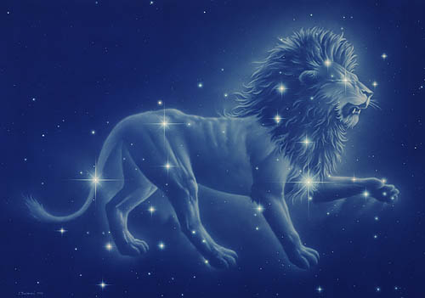

There’s Leo there, the mighty lion

That Hercules overcame

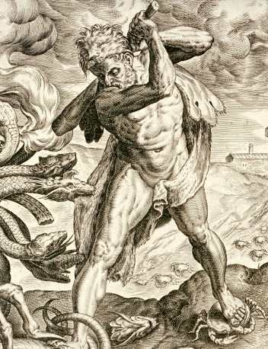The task that first brought him

To everlasting fame

And there’s the crab that Hera sent

To join the Hydra’s fight

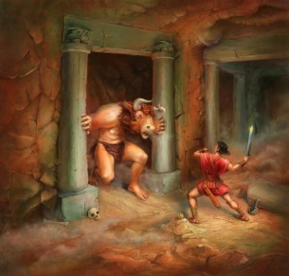Crushed by Hercules, the crab was then

Hung up in the night

That red star there, the eye of the bull

They called the minotaur

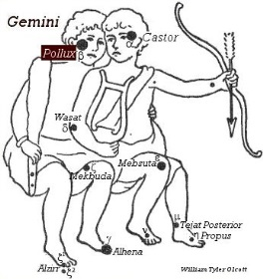That was killed by Theseus

Guided by thread along the floor

There’s Castor, Pollux; heavenly twins

One boxes, one’s a jockey

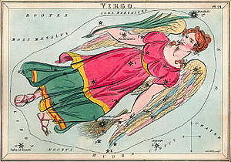And both of them can calm the waves

When a sea journey is getting rocky

There’s the young Persephone

In the shape that we call Virgo

With the bright star of the ear of wheat

Showing the crops that we grow

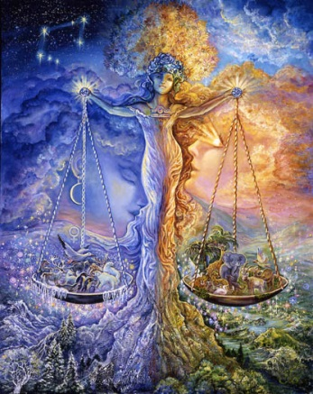The equal length of day and night

Is shown by Libra’s scales

And now that most of us are asleep

I will end my tales”

The fire burnt low, the travellers slept

The stars moved on their way

Marching across the sky above

Until hid by break of day